

AIR CHARTER SERVICES
CONTRACT № BA HU\03-___
Baku, Azerbaijan ________

FLIGHT 1 | Date | Departure  Location | Departure  Time | Arriving  Location | Flt. Time | Nr.Pax
FLIGHT 2 | Date | Departure  Location | Departure  Time | Arriving  Location | Flt. Time | Nr.Pax
Charter Type |  | Aircraft Type |  |  | Max. Seating Capacity
VIP |  | Gulfstream G550 (4K-MEK8) |  |  | 18
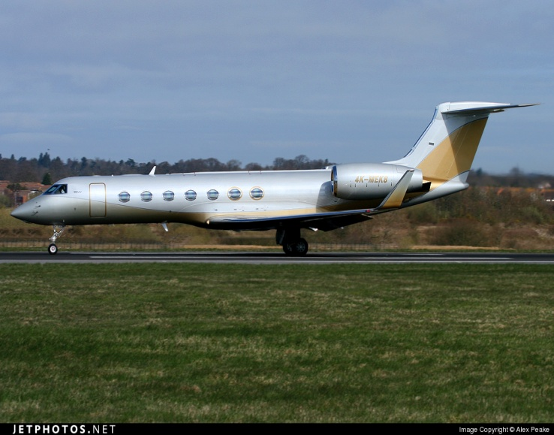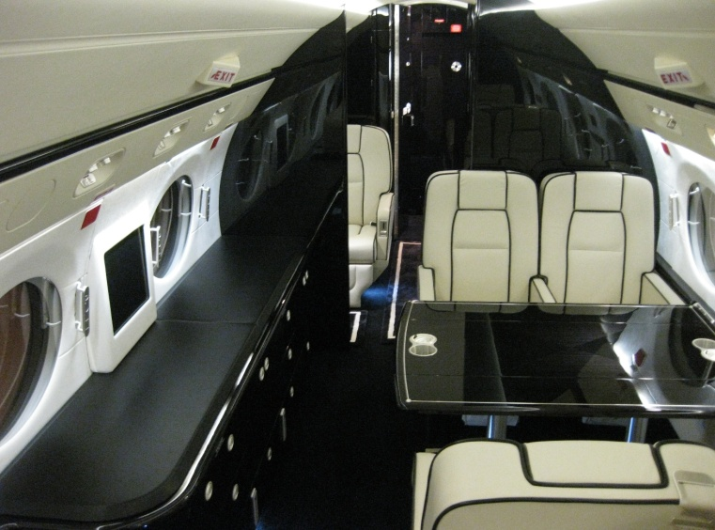
Client Details
Name:
Surname:
E-Mail Adress:
Phone:
Mobile:

Baku, Azerbaijan
BA HU\03-____

This Agreement is entered into by and between Silk Way Business Aviation LLC. (hereinafter referred to as “the Carrier”), represented by Director B.Guliyev, and _______________________________ (hereinafter referred to as “the Customer”) represented by ______________.

Silk Way Business Aviation LLC and _______________________________ collectively referred to us in this Agreement as "the Parties".

Now therefore for valuable consideration given and received and by their mutual covenants to abide by the laws of the Republic of Azerbaijan, International treaties, the Civil Code and the Aviation Law of the Republic Azerbaijan, International rules of transportation of passengers, hand luggage and cargo by air, the Parties hereby agree as follows:

- DEFENITIONS AND INTERPRETATION.
For the purposes of this Agreement the following words and phrases shall have the following meanings:
-Carrier shall mean the aircraft carrier Silk Way Business Aviation Ltd. who carries the Customer.
-Air transportation shall mean provision of services to the passenger under the terms of the Contract as defined by the Warsaw Convention.
-Execution of the air transportation service shall mean the provision of air transportation services under the Contract.
-Documents shall mean appendixes, amendments, addenda and additional agreements to the Contract, invoices, certificates of acceptance, etc. properly filled and signed.

2. SUBJECT OF THE CONTRACT.
2.1. The Carrier provides the Customer with air transportation services. Special terms and cost of transportation are determined in the additional agreements which form a part of the Contract.
2.2. The Customer pays for the entire commercial capacity of the aircraft performing air transportation upon the terms of the Agreement, appendixes and addenda, which form a part of the Agreement.

  - RIGHTS AND OBLIGATIONS OF THE PARTIES.
The Carrier shall have the following obligations:
3.1.1. to organize air transportation of passengers on the route specified above;
3.1.2. to control timely obtaining of all permits and licenses for flight operations required by laws and rules of the countries of departure and destination, as well as provide over flight clearances required by the Contract;
3.1.3. to provide passenger and luggage handling and registration in departure and arrival airports according to the flight schedule;
3.1.4. to provide on-board catering for passengers according to classes of servicing and established norms;
3.1.5. Timely and rapidly inform the Customer of deviations from the flight schedules as well as of any other services rendered.
3.2. The Carrier shall have the right to replace the aircraft type not amending terms and conditions of the Contract, if prior written notification is provided to the Customer.
3.3. The Customer shall have the following obligations:
3.3.1. to make timely payment for services supplied by the Carrier under the terms of the Contract;
3.3.2. to make sure passengers have all necessary entry and departure documents;
3.3.3. to provide the Carrier with all information necessary to organize the flight.

4. PAYMENTS AND SETTLEMENTS.
4.1. Payment shall be made in advance in accordance with the invoice issued, within 1 (one) day from the date of its issuance. Transaction expenses on the sender’s side are to be paid by the Carrier, transaction expenses on the recipient’s side are to be paid by the Customer.
4.2. Transportation shall be considered fully paid upon the transfer of the necessary sum on the Carrier’s account.

_____________
BA HU\03-____

4.3. According to this contract the total cost of charter services is specified in the appendix №1 and should include the services delivered in the airports and in a way, including:
- aircraft insurance and third party liability costs
- fuel cost
- ground handling
- airport fees
- aircraft parking costs
- operational costs of aircraft provision
- catering
- aircraft technical support costs
- pilots’ and stewards’ salaries
- aircraft maintenance costs
- air navigation services,
- crew
- any other costs relating to organization of the flight aircraft charter.
4.4 Payments can be made in Euros (EUR), U.S. dollars or in manat (AZN) at the rate of the National Bank of Azerbaijan Republic on the day of wire transfer.
4.5. The total cost excludes Ground transportation, royalties, non-objection fees, visas, government fees and taxes, customs duties which if levied will be charged to the Carrier.

5. RESPONSIBILITIES OF THE PARTIES.
5.1. In case of non-fulfillment or improper fulfillment by the Parties of their obligations under this Contract, the Parties shall bear responsibility in accordance with the effective legislation of the Republic of Azerbaijan and international conventions.
5.2. In case of rejection of the air transportation by any of the Parties, the guilty party shall pay a penalty, whose rate shall be determined under an additional agreement to this Contract and shall form an integral part hereof.
5.3. The Carrier shall bear no responsibility to the Customer in case of untimeliness or impossibility to obtain permits for the flight from aviation authorities by reasons beyond the Carrier’s control.
5.4. In case of any mechanical breaking (aircraft on the ground) of the aircraft, the Carrier within the shortest possible time shall provide to the Customer another aircraft with similar characteristics.

6. Reconfirmation.
6.1. Upon receipt of this Aircraft Charter Contract, Customer shall confirm their acceptance of such terms and conditions by returning this document already duly signed within 48 hours from receipt thereof, as otherwise the flight booking shall be considered cancelled and Carrier may use, assign or utilize the aircraft for other purposes or contracted to other parties.

7. CANCELLATION POLICY.
7.1. If the Customer wishes to cancel any Flight or Flights the subject of this Agreement the following rates will be paid forthwith by the Customer to the Carrier as agreed compensation:
10% of the Charter Price if cancelled after signed contract exchange;
25% of the Charter Price if cancelled within 10 days prior to DT;
50% of the Charter Price if cancelled within 72 hours prior to DT;
75% of the Charter Price if cancelled within 48 hours prior to DT;
100% of the Charter Price if cancelled 24 hours prior to DT.

8. PASSENGER AND CARGO ENTRY DOCUMENTS.
8.1 All passengers have to comply with any requirements (e.g. immigration, customs, agriculture, etc.) at each destination. Passengers have to be in possession of a valid passport plus, where necessary, a visa. Carrier takes absolutely no responsibility in case of non-compliance with any requirement by the passenger(s).
8.2 Should there be any surcharges, fees, fines or similar due to non-compliance, the customer will be billed for such costs. Carrier takes absolutely no responsibility with the regard to visa requirements of passengers. Should there be any levy due to the lack of required entry documents of passengers or cargo the customer will be billed for such costs.

________________
BA HU\03-____
9. FORCE MAJEURE.
9.1. Each Party to this Contract shall be released from responsibility for partial or complete non-fulfillment of its obligations hereunder if this non-fulfillment was caused by force majeure circumstances, including the following ones: acts of God, changes in weather conditions, strikes, actions of governmental and other state authorities and organizations.
9.2. Any Party, which is prevented from fulfillment of its obligations by force-majeure circumstances, shall be obliged to immediately notify the other Party of occurrence of the above force-majeure circumstances.
8.3. Losses incurred in connections with occurrence of force-majeure circumstances shall be born by the Parties individually.
9.4. The Carrier shall bear no responsibility if according to the above reasons it would be necessary to change the destination place, to delay or to cancel the flight, to make additional landings for the flight safety, to make repair works and to abort the flight.
9.5. All costs related to changes in place of destination, flight schedule, making additional landing and repair by reasons specified in paragraphs 5.1. and 5.4. shall be paid by the Carrier.
10. EFFECTIVE PERIOD OF THE CONTRACT.
10.1. This Contract shall come into force from the time of its signature and shall be considered to be executed upon fulfillment by the Parties of their obligations hereunder.
11. PASSENGER BAGGAGE.
11.1 Passenger baggage weight is limited for flight safety reasons and varies according to between aircraft type. Items determined by the crew to be of excessive weight or size will not be permitted on the aircraft
12. PROHIBITED OR DANGEROUS GOODS.
12.1 Dangerous goods must be declared as per dangerous goods regulations. Goods must be packaged and marked correctly according to the appropriate authorities.
Copies of the relevant regulations are available from Carrier on request.
13. SMOKING.
13.1 Smoking is prohibited on the aircraft.
14. FINAL PROVISIONS.
14.1. Any amendments, protocols and addenda to this Contract or appendixes hereto shall be made in writing and signed by the Parties.
14.2. All disputes and controversy, which may arise during conclusion, execution or cancellation of this Contract shall be settled by the Parties through negotiations. If the Parties fail to settle their disputes through negotiations they shall refer them for consideration to the Economic Court of the Republic of Azerbaijan.
14.3. Terms and conditions of this Contract shall constitute commercial secrets. The parties must not disclose terms and conditions of this Contract as well as any information concerning its execution unless prior written approval of another Party is provided.
14.4. This Agreement is signed in two equally authentic copies in English and each party holds one.
14.5. All notices shall be made in writing and shall be deemed to have been properly given if sent by telegraph, telex or fax (e-mail).
15. BANK DETAILS
CARRIER |  | CUSTOMER
“Silk Way Business Aviation” LLC  TAX # 1401135911  Euro account –  AZ50AZAL40150000001000002080  Bank name - “Bank Silk Way” Open Joint-Stock Venture Branch 2/ Baku AZ  SWIFTcode: AZALAZ22  Intermediary Bank- Raiffeisen Zentralbank Oesterich AG  SWIFTcode: RZBAATWW  Acct: 1-55.082.150/EUR  Director  ________________ B.Guliyev |  | _____________

Baku, Azerbaijan _________, 2013
Appendix № 1 to the contract
№ BA HU\03-____

This Appendix referring to the section 2.1 of the Air charter services contract signed ____________, 2012 (date), is entered into by and between Silk Way Business Aviation Ltd. (hereinafter referred to as “Carrier”), represented by Director B.Guliyev and ______________________ (hereinafter referred to as “the Customer”) represented by ____________________.

Now therefore for valuable consideration given and received and by their mutual covenants, the Parties hereby agree as follows:

Cost of service: _________ USD (______________________________ dollars).

Payments can be made in Euros (EUR), U.S. dollars or in manat (AZN) at the rate of the National Bank of Azerbaijan Republic on the day of wire transfer.

Note: The total cost excludes ground transportation, de-icing, royalties, non-objection fees, visas, government fees and taxes, customs duties which if levied will be charged to the Carrier.

CARRIER |  | CUSTOMER
“Silk Way Business Aviation” LLC  TAX # 1401135911  Euro account –  AZ50AZAL40150000001000002080  Bank name - “Bank Silk Way” Open Joint-Stock Venture Branch 2/ Baku AZ  SWIFTcode: AZALAZ22  Intermediary Bank- Raiffeisen Zentralbank Oesterich AG  SWIFTcode: RZBAATWW  Acct: 1-55.082.150/EUR  Director  _______________ B.Guliyev |  | _____________

